Factoring 1 7/20

Factor the following expressions:

1) x2 - 6x - 27 2) x2 + 11x + 18 3) x2 + 5x - 24

4) x2 - 10x + 21 5) -x2 - 10x - 9 6) 2x2 - 4x - 20

7) Write the polynomial modeled then factor.

a) 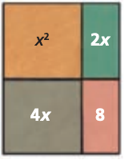 b) 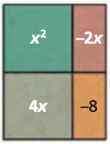

7) Find all possible values if b so that x2 + bx + 6 can be factored into binomial factors.

8) The area of a rectangular fountain is (x2 + 12x + 20) ft2. The width is (x + 2) ft.

1. Find the length of the fountain.
2. A 2-foot walkway is built around the fountain. Find the dimensions of the outside border of the walkway.
3. Find the total area covered by the fountain and walkway.